

AI Driven SQA: Manual & Automation Testing

Assignment 02

Module: 02
Topic: Software Development Life Cycle (SDLC)
in the Age of AI.

Submitted by,
Name: Jhion Adbar Opi
Batch: 21
Phone: 01778812373
Q1. Draw the SDLC lifecycle diagram and briefly explain the workflow?
Answer: Software Development Life Cycle (SDLC) is a structured process used to plan, design, develop ,deploy and maintain software high-quality software systematically. It ensures a systematic workflow and helps align software development with business goals and user requirements. It consists of several phases that guide a software project from planning to maintenance.
Stages of the Software Development Life Cycle:

Requirement Analysis
: Gather and analyze customer requirements.

Design
: Create system architecture and technical design.
Maintenance
Fix bugs and improve the software after release.

Software Development Life Cycle (SDLC) Phase

Deployment
: Release the software to users.
Implementation (Development)
: Develop the software through coding.

Testing
: Verify functionality and identify defects.

Phase 1: Requirement Analysis Phase.
In this phase, the development team communicates with clients and stakeholders to understand business and user requirements. Documents such as BRD, SRS, Use Case, RTM are prepared.
Activities
- Meet with clients and stakeholders.
- Gather business requirements.
- Identify user requirements.
- Define functional requirements.
- Define non-functional requirements.
- Identify system constraints.
- Prepare BRD (Business Requirement Document).
- Prepare SRS (Software Requirement Specification).
- Review and approve requirements.
Phase 2: Requirement Analysis Phase.
After requirements are approved. System architecture and technical design are created. This phase includes High-Level Design (HLD), Low-Level Design (LLD), database design, API design and UI/UX design.
Activities
- High-Level Design (HLD).
- Low-Level Design (LLD).
- Database Design.
- API Design.
- UI/UX Design.

Phase 3: Implementation (Development) Phase.
Developers convert the approved design into working software by writing source code. Activities include coding, code review, unit testing, version control and CI/CD integration.
Activities
- Coding
- Code Review
- Unit Testing
- Version Control (Git)
- Integration test
- CI/CD Integration

Phase 4: Testing Phase.
The QA team verifies that the software meets the specified requirements and is free from critical defects. Testing activities include.
Activities
- Test Planning
- Test Case Design (Verifies individual components).
- Test Execution (Ensures modules work together).
- Defect Reporting.
- Regression Testing.
- Retesting.
- Automation Testing.
- Performance Testing.
- Security Testing.
- User Acceptance Testing (Confirms business requirements are met).

Phase 5: Deployment Phase.
Once testing is completed successfully, the application is released to the production environment for end users. Deployment activities include.
Activities
- Production Release.
- Database Migration.
- Configuration Updates.
- Smoke Testing.
- Monitoring.
- Rollback Planning.
Phase 6: Maintenance.
After deployment, the software is continuously maintained to fix bugs, improve performance, add new features, and apply security updates. This phase continues throughout the software's lifecycle.
Activities
- Bug Fixing
- Performance Improvement
- Feature Enhancement
- Security Patch Updates
- Customer Support
- Monitoring

The upper describe SDLC provides a systematic approach to software development.

Q2. Practical AI Exercise.
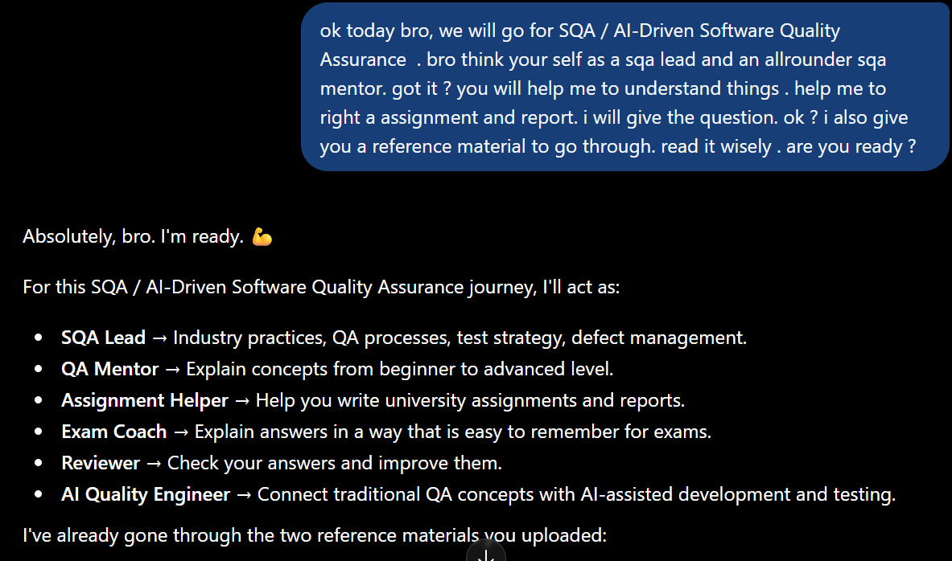
Answer: For this requirement I have use ChatGPT as AI tool to understand Agile Scrum + AI-Augmented Development + Human Review.

Fig 01- Above photo is about AI Setup.
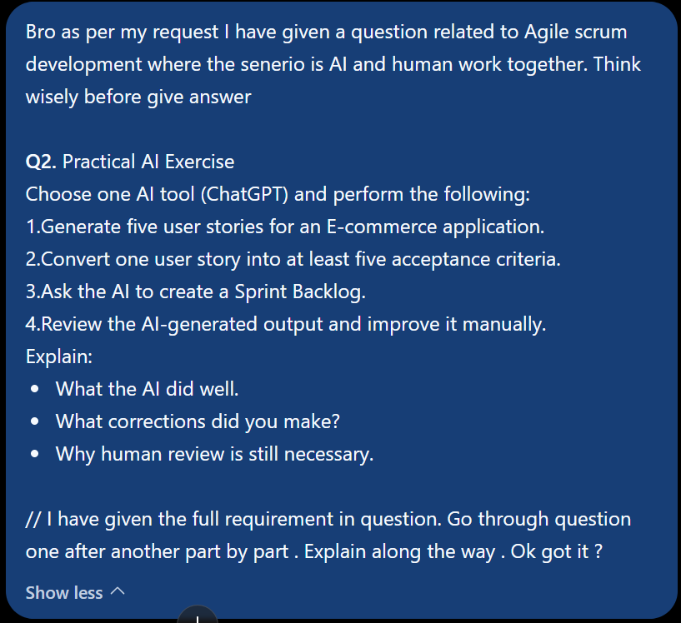

Fig 02- Above photo is about the prompt given to the AI .
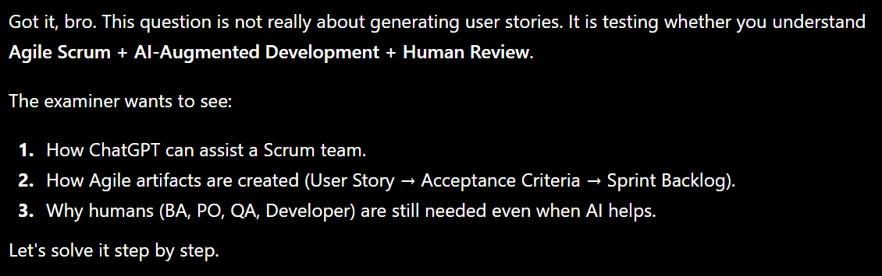
Fig 03- Above photo is about the prompt startup of AI .

01. Generate five user stories for an E-commerce application.
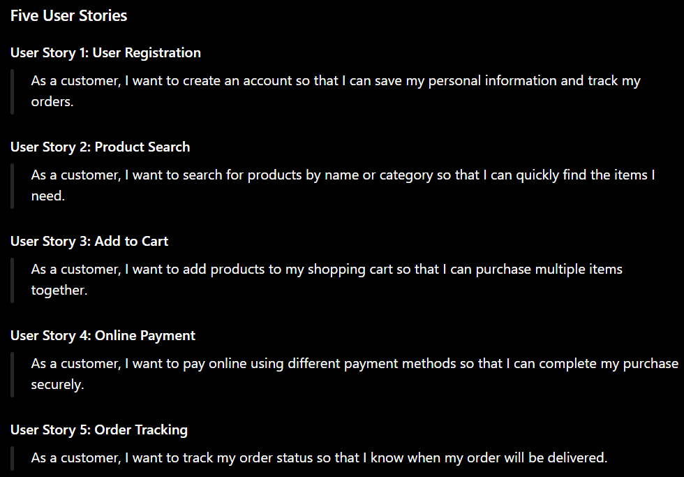
Ans: Using ChatGPT, five user stories were generated for an E-Commerce application. The generated user stories focused on common customer activities such as registration, product search, cart management, online payment, and order tracking. These user stories follow the standard format:

Fig 04- Generate Five User Stories for an E-Commerce Application.
As by the AI prescriptive why these given stories are good.
- User-focused
- Simple and clear
- Describe business value
- Common features of an E-Commerce application
02. Convert one user story into at least five acceptance criteria.

Ans: The user story "Online Payment" was selected and converted into acceptance criteria. The acceptance criteria describe the specific conditions that must be fulfilled for the feature to be accepted.

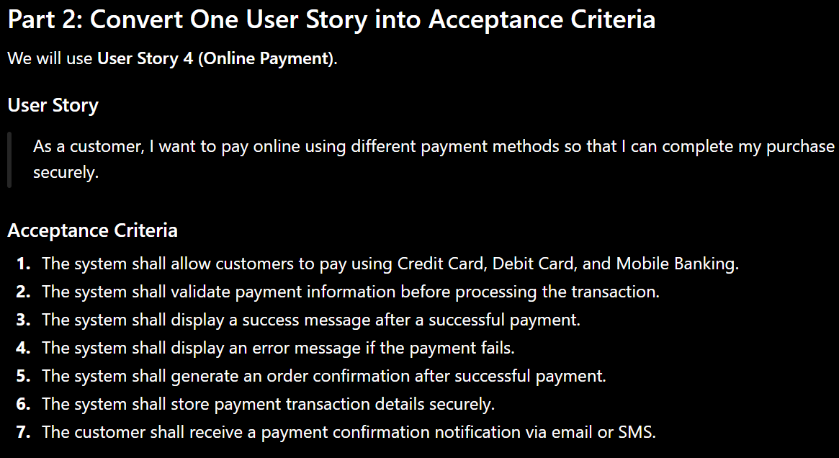
Fig 05- Acceptance Criteria for online payment.

As by the ChatGPT describe acceptance criteria that define the conditions which must be satisfied before a user story is considered complete. For this user story, the criteria ensure:
- Multiple payment options are available.
- Payment data is validated.
- Success and failure scenarios are handled properly.
- Order confirmation is generated.
- Customer receives confirmation.
- Security requirements are maintained

03. Convert one user story into at least five acceptance criteria.
Ans: ChatGPT has create the Sprint Backlog for the user story:
US-04: As a customer, I want to pay online using different payment methods so that I can complete my purchase securely.
Sprint Summary
Item | Value
Sprint ID | Sprint-03
Sprint Goal | Secure Online Payment Feature
Total Tasks | 22
User Story ID | US-04
Total Estimated Effort | 129 Hours
 | 2 Weeks
  Sprint Duration
Status
  In Progress
Table 01- Sprint Summary
Sprint Backlog
Sprint Name: Sprint 3 – Online Payment Feature
Sprint Duration: 2 Weeks
Sprint Goal: Implement and test secure online payment functionality for the E-Commerce application.
Task ID | User Story ID | Task Description | Assigned To | Priority | Status | Estimated Effort
TASK-01 | US-04 | Analyze payment requirements and acceptance criteria | Business Analyst | High | Incomplete | 4 Hours
TASK-02 | US-04 | Design payment module architecture | Solution Architect | High | Incomplete | 6 Hours
TASK-03 | US-04 | Design database tables for payment transactions | Database Engineer | High | Incomplete | 4 Hours
TASK-04 | US-04 | Create payment API specifications | Backend Developer | High | Incomplete | 5 Hours
TASK-05 | US-04 | Develop Credit Card payment integration | Backend Developer | High | Incomplete | 10 Hours
TASK-06 | US-04 | Develop Debit Card payment integration | Backend Developer | High | Incomplete | 8 Hours
TASK-07 | US-04 | Develop Mobile Banking payment integration | Backend Developer | High | Incomplete | 8 Hours
TASK-08 | US-04 | Develop payment user interface | Frontend Developer | High | Incomplete | 8 Hours
TASK-09 | US-04 | Implement payment validation logic | Backend Developer | High | Incomplete | 6 Hours
TASK-10 | US-04 | Implement payment success and failure messages | Frontend Developer | Medium | Incomplete | 4 Hours
TASK-11 | US-04 | Generate order confirmation after successful payment | Backend Developer | High | Incomplete | 5 Hours
TASK-12 | US-04 | Implement email/SMS payment notification service | Backend Developer | Medium | Incomplete | 6 Hours
TASK-13 | US-04 | Encrypt and securely store transaction data | Security Engineer | High | Incomplete | 6 Hours
TASK-14 | US-04 | Prepare test plan and test cases | QA Engineer | High | Incomplete | 5 Hours
TASK-15 | US-04 | Execute functional testing | QA Engineer | High | Incomplete | 8 Hours
TASK-16 | US-04 | Execute payment validation testing | QA Engineer | High | Incomplete | 5 Hours
TASK-17 | US-04 | Execute security testing | QA Engineer | High | Incomplete | 6 Hours
TASK-18 | US-04 | Log and track defects | QA Engineer | High | Incomplete | 4 Hours
TASK-19 | US-04 | Fix reported defects | Development Team | High | Incomplete | 8 Hours
TASK-20 | US-04 | Conduct User Acceptance Testing (UAT) | Product Owner & Users | High | Incomplete | 6 Hours
TASK-21 | US-04 | Deploy payment feature to production | DevOps Engineer | High | Incomplete | 4 Hours
TASK-22 | US-04 | Perform post-deployment smoke testing | QA Engineer | High | Incomplete | 3 Hours

Table 02 - Sprint Backlog

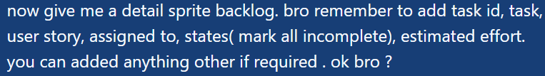
Prompt was use:
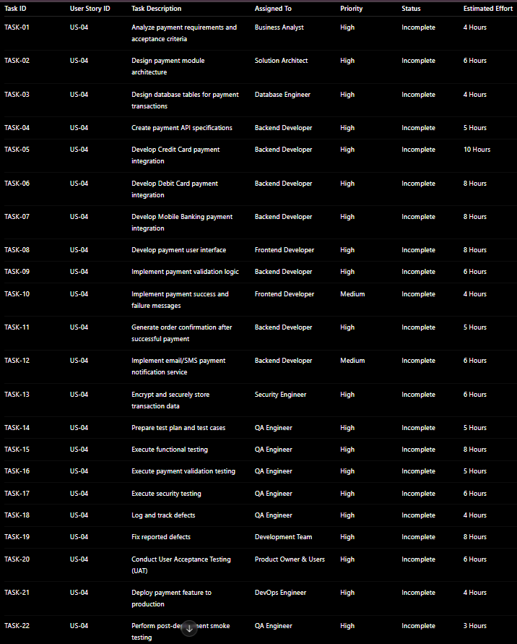
Fig06 – Prompt for Sprint

Fig 07- Sprint Backlog
04. Review the AI-generated output and improve it manually.
Explanation: The AI-generated output included five user stories. Acceptance criteria for the Online Payment feature and a Sprint Backlog containing development, testing, security and deployment tasks. After reviewing the output, several strengths and areas for improvement were identified.

4.1 What the AI did well.
AI was able to generate useful project artifacts quickly and efficiently.

a. Generated Clear User Stories
The AI created user stories using the standard Agile format:
[ As a customer, I want ..., so that ... ]

This structure clearly identifies:
- The user
- The desired functionality
- The business value

b. Created Relevant Acceptance Criteria
The AI converted the selected user story into measurable acceptance criteria.
AS_
- Support multiple payment methods.
- Validate payment information.
- Display payment success and failure messages.
- Generate order confirmation.

These criteria help developers understand feature requirements and help QA engineers prepare test cases.

c. Generated a Structured Sprint Backlog
The AI divided the user story into smaller tasks such as:
- Requirement analysis
- System design
- API development
- UI development
- Testing
- Deployment

Breaking large requirements into smaller tasks makes Sprint planning easier.

d. Included Multiple Team Roles
The AI assigned tasks to different team members such as:

- Business Analyst
- Backend Developer
- Frontend Developer
- QA Engineer
- Security Engineer
- DevOps Engineer

This reflects how real Agile teams collaborate.
e. Included Effort Estimation
The Sprint Backlog included estimated effort for each task.
This helps the Scrum Team:
- Estimate Sprint capacity
- Track workload
- Plan Sprint delivery

f. Covered the Entire Development Lifecycle
The AI-generated backlog covered activities from requirement analysis to deployment and testing.
This aligns with SDLC phases such as:
- Requirement Analysis
- Design
- Implementation
- Testing
- Deployment
- Maintenance

4.2 What Corrections Were Made?
Although the AI-generated output was useful, several improvements were required after manual review.

Correction 1: Add Task Dependencies
Problem
The AI listed tasks independently. However, in real projects some tasks cannot begin until others are completed.
Example Incorrect Approach:

- Functional Testing
- Payment API Development

Correct Approach:
Payment API Development
↓
Functional Testing
↓
User Acceptance Testing

Improvement
Task dependencies were added to clarify execution order and Sprint workflow.

Correction 2: Improve Task Granularity
Problem: Some tasks were too broad.
Execute Functional Testing: This task can actually involve multiple testing activities.
Improvement
The task was divided into:
- Test Case Preparation
- Functional Testing
- Integration Testing
- Regression Testing
- UAT Support
This provides better tracking and visibility.
Correction 3: Add Risk Management Activities
Problem: The AI did not include risk-related tasks. For an online payment system, risk management is extremely important.
Improvement
Additional tasks were added:
- Security Risk Assessment
- Payment Gateway Failure Analysis
- Rollback Planning
These tasks reduce operational and security risks.

Correction 4: Refine Effort Estimation
Problem: The effort estimates generated by AI were generic.
AI cannot accurately determine:
- Team skill level
- Project complexity
- Existing infrastructure
- Technical constraints

Improvement
Effort estimates were reviewed and adjusted based on realistic project conditions.

Correction 5: Add Definition of Done (DoD)
Problem: The AI did not define when a task is considered complete.
Improvement
The following Definition of Done was added:
- Code Review Completed
- Test Cases Passed
- No Critical Defects
- Documentation Updated
- Product Owner Approval Received

This ensures consistent quality standards.

Correction 6: Improve Security Coverage
Problem: Although AI mentioned secure transaction storage, it did not provide enough emphasis on security validation.
Improvement
Additional QA activities were included:
- Security Testing
- Data Encryption Verification
- Payment Validation Testing
- Vulnerability Assessment

These activities are critical for payment systems.

4.3 Why Human Review Is Still Necessary
AI is a powerful assistant. But it cannot replace us human expertise. So I Opi can say_

1. AI Lacks Business Context
AI generates output based on patterns, training data and given prompt.

It does not fully understand:
- Business goals
- Organizational policies
- Customer expectations
- Project priorities
Us humans provide the business context needed for accurate decision-making.

2. AI May Miss Critical Requirements
AI can generate good initial drafts. But it may overlook:
- Edge cases
- Compliance requirements
- Security concerns
- Performance requirements
Human reviewers identify these missing requirements.

3. AI Cannot Fully Assess Risk
Risk assessment often requires experience and domain knowledge.

As for example an experienced QA Lead may identify:
- Payment fraud risks
- Data privacy risks
- Regulatory compliance issues
AI may not recognize all project-specific risks.

4. AI Cannot Validate Real-World Feasibility
AI may suggest:
- Unrealistic timelines
- Incorrect effort estimates
- Impractical implementation approaches

Human experts validate whether the solution is achievable.

5. Quality Assurance Requires Human Judgment
Testing is not only about checking functionality.

QA engineers evaluate:
- Usability
- Reliability
- Security
- Customer experience

Many of these evaluations require human judgment and critical thinking.
6. Humans Are Responsible for Final Decisions
AI can generate recommendations. But it cannot take responsibility for project outcomes.
Final decisions must be made by:
- Product Owners
- Scrum Masters
- Project Managers
- QA Leads
- Development Teams
Humans remain accountable for software quality and project success.

End of discussion I Opi can say. Although AI can generate user stories, acceptance criteria and Sprint Backlogs quickly. Human review is still necessary to ensure accuracy, completeness and alignment with business requirements. AI may overlook important details such as project-specific risks, security concerns, dependencies and realistic effort estimations. Human experts use their experience, critical thinking and domain knowledge to validate AI-generated content, make necessary improvements and ensure the final output meets quality standards and project objectives.

